**Task No 1:**

**HTML code :**

<!DOCTYPE html>

<html lang="en">

<head>

    <meta charset="UTF-8">

    <meta name="viewport" content="width=device-width, initial-scale=1.0">

    <title>Document</title>

    <link rel="stylesheet" href="task 01.css">

</head>

<body>

    <h1>

        Start CSS Exercises

    </h1>

    <p>

        Good Luck

        </p>

        <button class="btn">

            start css exercise

        </button>

</body>

</html>

**CSS Code:**

.btn {

    background-color: rgb(4, 110, 64);

        color: aliceblue;

        border: none;

        height: 36px;

        width: 150px;

        border-radius: 2px;

        cursor:pointer;

        margin-right: 8px;

        transition: opacity 0.15s;

  }

  h1

{

    font-family: Times;

    color: aliceblue;

}

p

{

    font-family: Times;

    color: white;

}

  body {

    background-color: rgb(1, 19, 26);

  }

**Task No 2:**

**HTML code:**

<!DOCTYPE html>

<html lang="en">

<head>

    <meta charset="UTF-8">

    <meta name="viewport" content="width=device-width, initial-scale=1.0">

    <title>Document</title>

    <link rel="stylesheet" href="task 01.css">

</head>

<body>

    <form>

        <input type="text" id="name" name="name" placeholder="Name" required>

        <label for="name"></label>

       <input type="text" id="Username" name="Username" placeholder="Username" required>

        <label for="Username"></label>

        <input type="password" id="Pass" name="Pass" placeholder="Password" required>

        <label for="Pass"></label>

        <input type="text" id="Number" name="Number" placeholder="Number" required>

        <label for="Number"></label>

        <input type="email" id="Email" name="Email" placeholder="Email" required>

        <label for="Email"></label>

      </form>

      <button class="btn">

        Register

    </button>

</body>

</html>

**CSS code:**

.form

{

    color: aliceblue;

}

 body

{

    background-color: rgba(38, 79, 214, 0.755);

}

.btn {

    background-color: rgb(188, 19, 7);

        color: aliceblue;

        border: none;

        height: 20px;

        width: 170px;

        border-radius: 2px;

        cursor:pointer;

        margin-right: 8px;

        transition: opacity 0.15s;

  }

label

{

    color: rgb(232, 227, 227);

    font-size: 16px;

    display: block;

    margin-bottom: 5px;

    text-align: left;

}

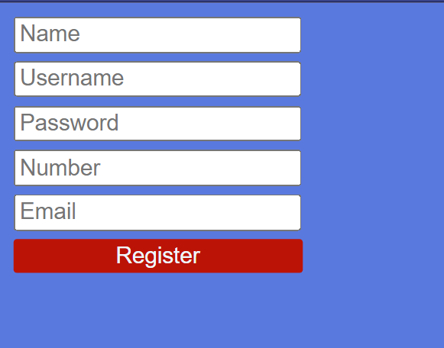

**Task No 3:**

**Html Code:**

<!DOCTYPE html>

<html lang="en">

<head>

    <meta charset="UTF-8">

    <meta name="viewport" content="width=device-width, initial-scale=1.0">

    <title>Document</title>

    <link rel="stylesheet" href="task 01.css">

</head>

<body>

    <div class="card">

        <img src="https://cdn.pixabay.com/photo/2018/08/14/13/23/ocean-3605547_960_720.jpg" alt="Avatar" style="width:100%">

        <div class="container">

          <h4><b>Sufyan Malik</b></h4>

          <p>WEB Developer</p>

        </div>

      </div>

</body>

</html>

**CSS code:**

.card {

    width: 500px;

  box-shadow: 0 4px 8px 0 rgba(0,0,0,0.2);

  transition: 0.3s;

}

.card:hover {

  box-shadow: 0 8px 16px 0 rgba(0,0,0,0.2);

}

.container {

  padding: 2x 16px;

  text-align: center;

}

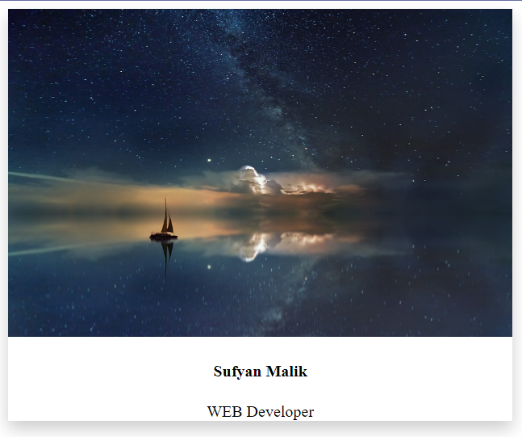

**Task No 4:**

**HTML code:**

<!DOCTYPE html>

<html lang="en">

<head>

    <meta charset="UTF-8">

    <meta name="viewport" content="width=device-width, initial-scale=1.0">

    <title>Document</title>

    <link rel="stylesheet" href="task 01.css">

</head>

<body>

    <div class="card">

        <img src="https://cdn.pixabay.com/photo/2018/08/14/13/23/ocean-3605547_960_720.jpg" alt="Avatar" style="width:100%">

        <div class="container">

          <h4><b>Sufyan Malik</b></h4>

          <p>WEB Developer</p>

        </div>

      </div>

</body>

</html>

**CSS code:**

.card {

    width: 500px;

  box-shadow: 0 4px 8px 0 rgba(0,0,0,0.2);

  transition: 0.3s;

}

.card:hover {

  box-shadow: 0 8px 16px 0 rgba(0,0,0,0.2);

}

.container {

  padding: 2x 16px;

  text-align: center;

}

.card {

    animation: slideIn 5s ease;

}

@keyframes slideIn {

    from {

        margin-left: -100%;

    }

    to {

        margin-left: 0;

    }

}

